

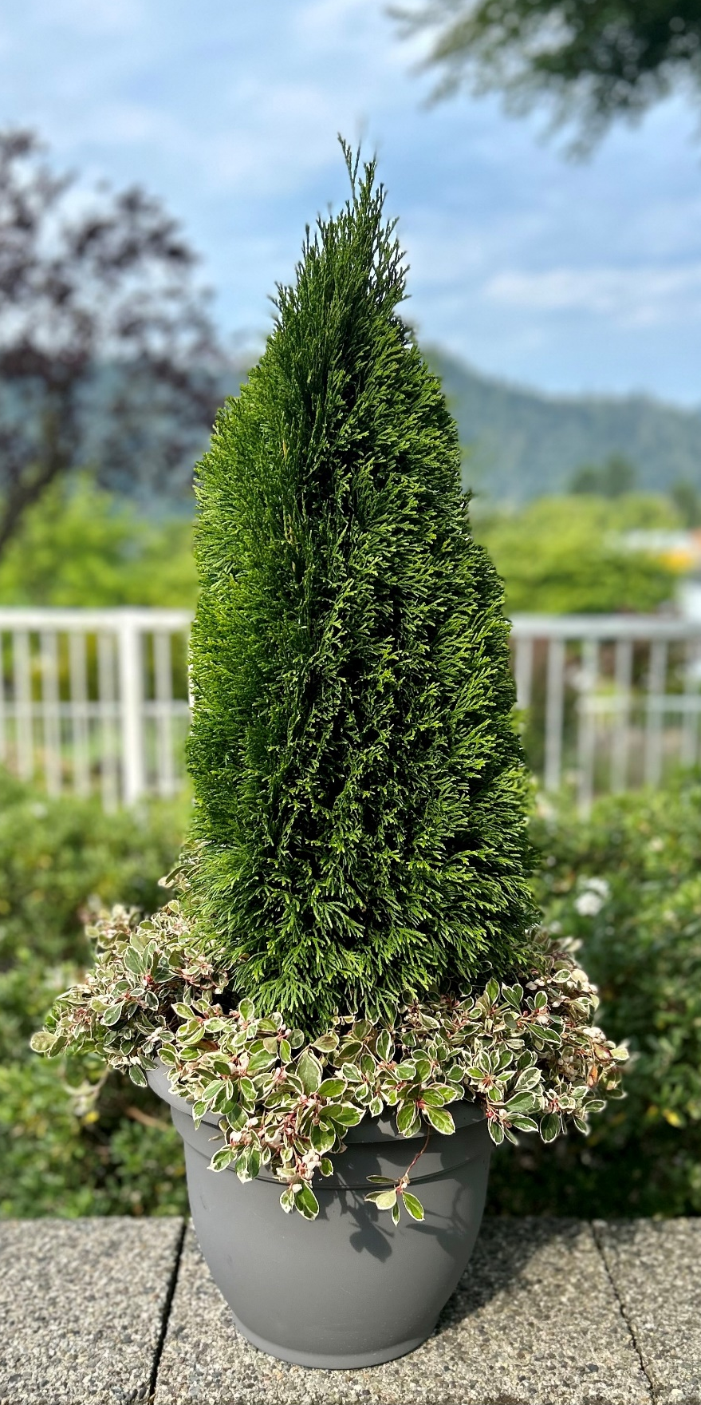
Our scaled down version of Emerald Green arborvitae
is a perfect fit for smaller spaces
and containers!

Dwarf cedar with a symmetrical, pyramidal habit, and glossy, bright green foliage in flat, lacy sprays. At a mature size of just 6’H x 2’W, ‘Emerald Petite’ is much smaller than its parent, with lacy foliage that is fuller and more densely packed. As with all Thuja, plant ‘Emerald Petite’ in full sun, in acidic, alkaline or neutral soil that
is moist, but well drained.
Zones 3 to 7.

PLEASE CALL FOR A COMPLETE LIST
OF AVAILABLE SIZES
& PRICING



(604) 826-3537
info@sidhunursery.com
www.sidhunursery.com

